CSWA Exam Guide:
- Overview of exam
- View types quiz/ definitions
- Important buttons/ shortcuts/ Icons
- Making planes
- Making origin
- Reading mass properties/ materials
- Mating
- Troubleshooting
- Part Practice
- Assembly Practice
- Notes Page

Questions/ Comments:
Leah:
Lynch.110@wright.edu
Jason:
Adams.443@wright.edu

Exam Overview:
Length: 3 hrs
Passing grade: 70%
Retest: 14 days
Regular cost: $100
General topics:
- Sketch entities - lines, rectangles, circles, arcs, ellipses, centerlines
- Sketch tools - offset, convert, trim
- Sketch relations
- Boss and cut features - extrudes, revolves, sweeps, lofts
- Fillets and chamfers
- Linear, circular, and fill patterns
- Dimensions
- Feature conditions – start and end
- Mass properties
- Materials
- Inserting components
- Standard mates - coincident, parallel, perpendicular, tangent, concentric, distance, angle
- Reference geometry – planes, axis, mate references
- Drawing views
- Annotations
Format:
Several multiple choice questions on view types
3 Parts (Easy, medium, hard) with 3 different iterations
2 Assemblies
View your exam states:
https://3dexperience.virtualtester.com/#account-main

View types quiz/ definitions:
For each of the following, identify and describe the view.
- 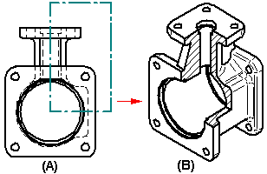

- 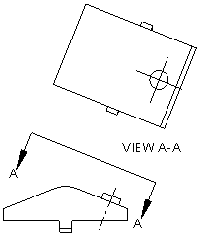

- 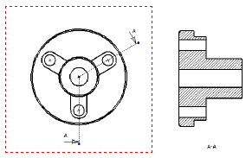

- 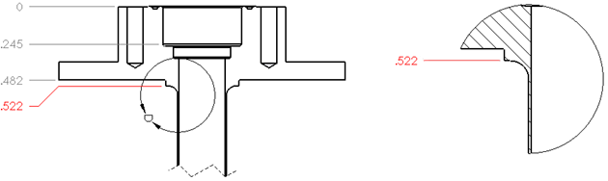

- 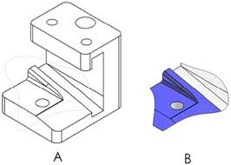

- 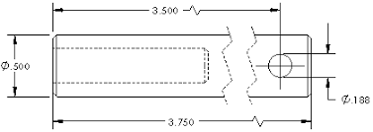

- 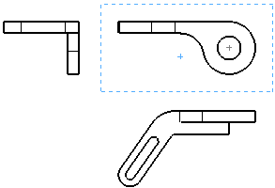

Answer Key:

- Broken out section view: exposes the interior geometry.
(Look for a bear took a big chunk out of the part)
- Auxiliary view: Looks perpendicular to the specified surface
(If there is a construction line at an angle, followed by a view looking perpendicular to that angle, it is probably an aux view)
- Section view: Cuts a part into a section on a “ cutting plane” to expose hidden geometry
(Look for a dotted line with an arrow on each end)
- Detail view: Magnifies a section to show the detail that is hard to see in the overall picture
(Look for a circle that has two arrows pointing at each other. Sometimes there are no arrows)
- Crop view: Isolates a section of a drawing
(is often still the same scale as the parent view)
- Break view: Shortens a long part by cutting out a long section that has no important or interesting geometry.
(Looks for a zig-zag line)
- Projected view: Unfolds a view into one of the 8 possible, standard directions.
(The three standard views (Top, front, and right) are also examples of this.)
Important buttons/ shortcuts/ Icons:
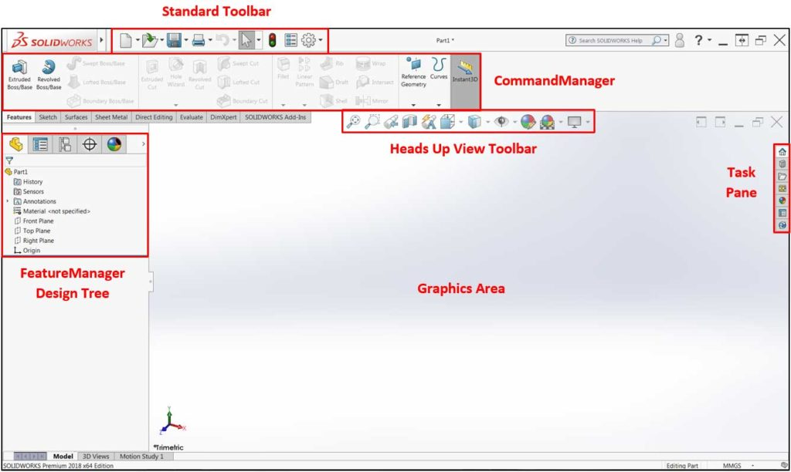
2D Sketches
3D Objects

View orientation:
Look normal to a plane: Spacebar -> choose panel that you wish to look normal to
Rotate component: Hold middle mouse
Zoom in/out: scroll wheel
Look normal to a surface: Right click on desired (flat) surface, click on
Add a relation: Hold control
Add a mate: Hold control
Smart dimension:
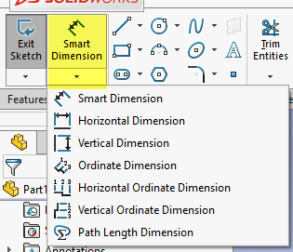
Or hold the right mouse button and slide upwards
Dimension between the apex of two arcs: Hold shift while dimensioning
Calculating dimensions: use the dimensioning input as an actual calculate (i.e. + - * /)
Convert a line to construction geometry: Right click

Part Practice:
Part 1:
Material: AISI 1020
What is the overall mass of the part in grams?
- 87.64 grams
- 11.09 grams
- 89.26 grams
- 11.30 grams
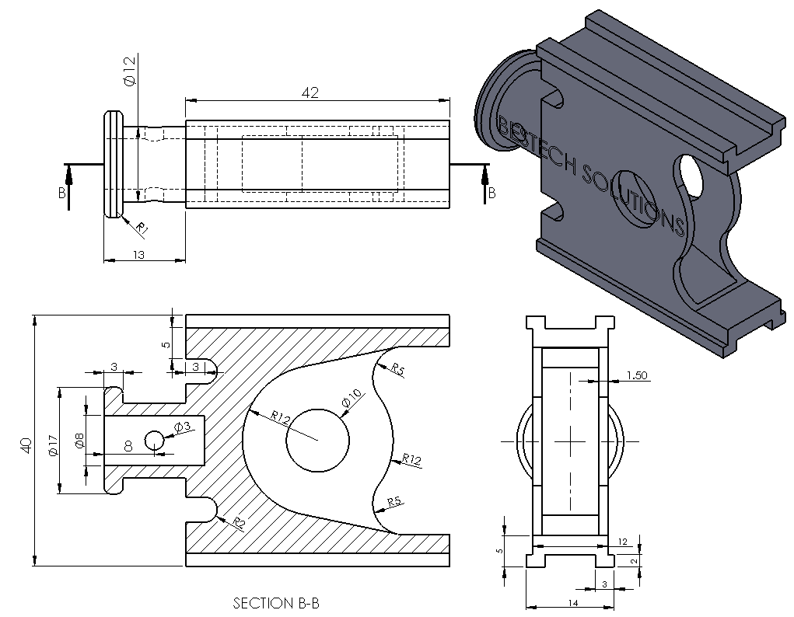
Answer: A

Part 1b: Make the following changes. x7 Holes. What is the new mass in grams?
Mass: ______grams
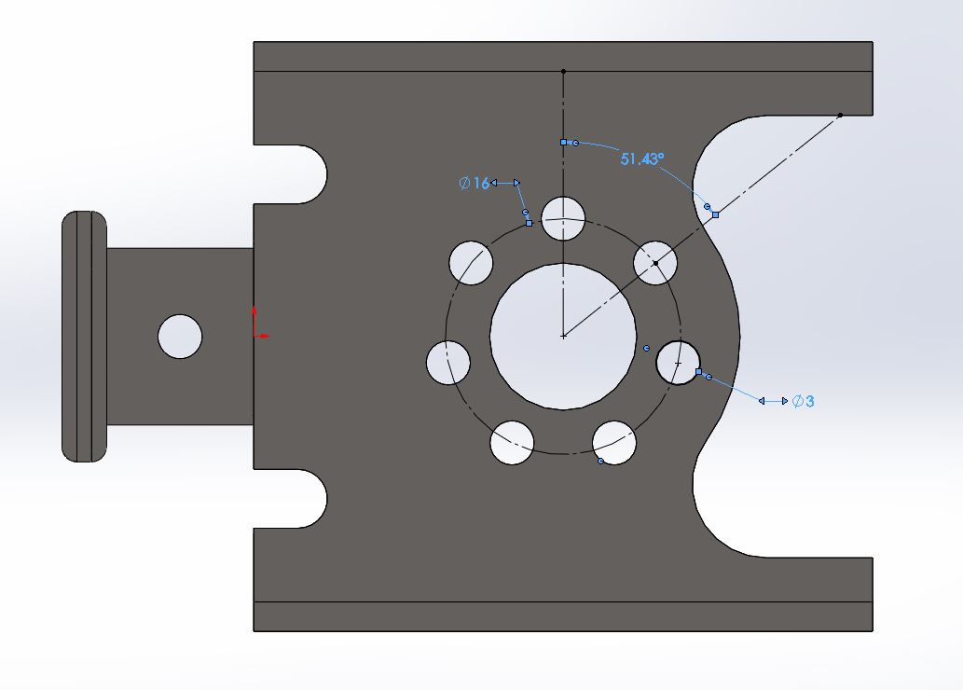
Answer: 86.47

Part1c: Front face shell of 0.10 mm. What is the center of mass of the part in mm?
X: _____mm
Y: _____mm
Z: _____mm
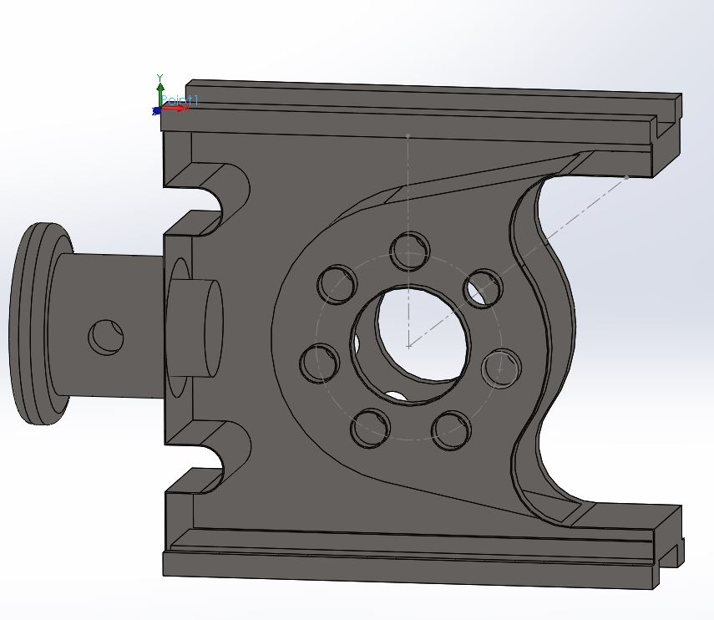
Answer:
X = 14.59 mm
Y = -20.00 mm
Z = -7.89 mm

Assembly Practice:
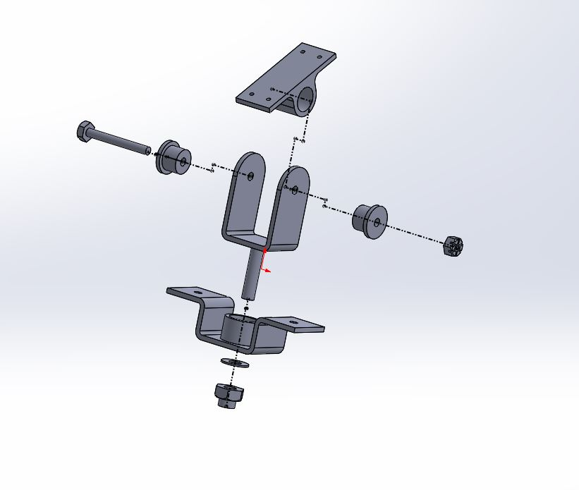
Build the assembly. Angle A is 50 degrees. What is the center of mass of the assembly?
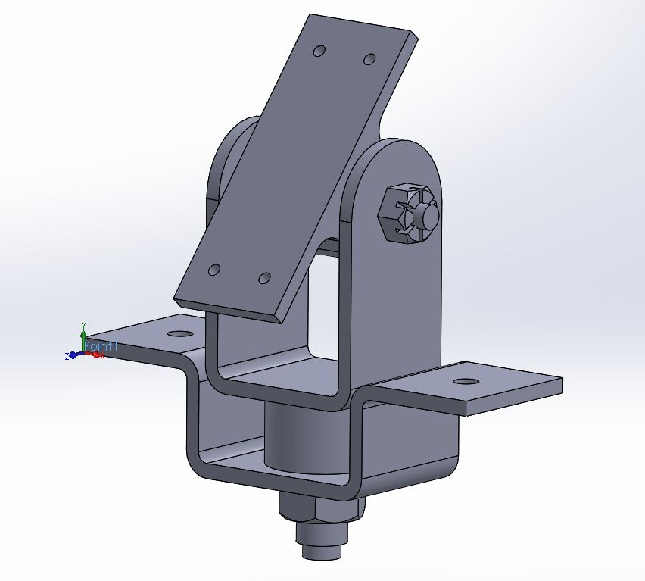
A

X = 415.07 mm
C
A
Y = 398.76 mm
Z = 691.17 mm

X = 475.81 mm
D
B
Y = 139.09 mm
Z = -138.03 mm

X = 475.81 mm
Y = 142.58 mm
Z = -142.19 mm

X = 415.07 mm
Y = 402.25 mm
Z = 687.01 mm

Center of mass of assembly:
X: ______ mm
Y: ______ mm
Z: ______ mm

Answer: B
What is the mass of the part in grams?
Mass: _____grams

Change angle A to 30 degrees. What is the new center of mass of the part in mm?
X: ______ mm
Y: ______ mm
Z: ______ mm

Answer:
X = 475.81 mm
Y = 142.58 mm
Z = -142.19 mm

Notes:

________________________________________________________________________

________________________________________________________________________

________________________________________________________________________

________________________________________________________________________

________________________________________________________________________

________________________________________________________________________

________________________________________________________________________

________________________________________________________________________

________________________________________________________________________

________________________________________________________________________

